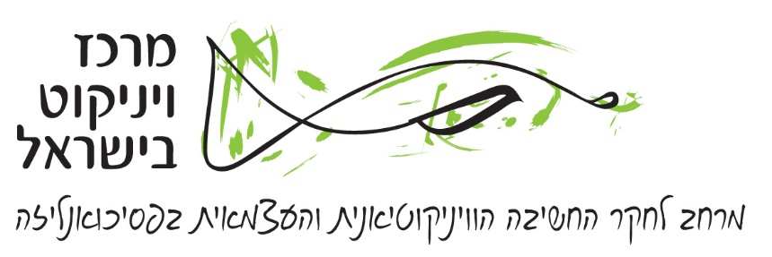

**The Work of Christopher Bollas**

Seminar led by Sarah Nettleton

Participants are asked to read the folllowing papers by Bollas before the seminar:

Seminar 1: Theories of the Unconscious

1. What is theory? *The Freudian Moment* (Karnac 2007) pp 71-83

Seminar 2: Human Idiom

2. Being a character *Being a Character* (Routledge 1993*)* pp 47-65

3. Normotic illness *The Shadow of the Object: Psychoanalysis of the Unthought Known* (Free Association Books 1987) pp 135-156

Seminar 3: The Evocative Object

4. The evocative object *Being a Character* pp 33-46

5. Architecture and the unconscious *The Evocative Object World*

(Routledge 2009) pp 47-77

Seminar 4 & 5: Free Association

6. Free association *The Evocative Object World* pp 5-45

(NB This chapter was previously published by Icon in 2002. Either version will do.)

7. Psychic transformations *The Freudian Moment* pp 1-32

* * * * *

This interview with Christopher Bollas is also recommended as background reading:

Chapter 1 from *Freely Associated,*  ed.Molino (Free Association Books 1997)



**תוכנית הסמינר**

**יום חמישי, 8.2.18, בתיכונט:**

**16:00** סמינר 1

**17:30** הפסקה

**18:00** סמינר 2

**19:30** סיום

**יום ראשון, 11.2.18, בבית השחמט:**

**08:30** סמינר 3

**10:00** הפסקה

**10:15** סמינר 4

**11:45** הפסקה

**12:15** סמינר 5

**13:45** סיום